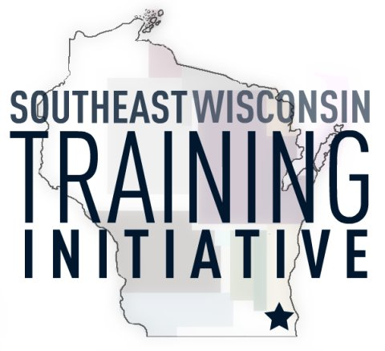
Integrative Psychiatry:
Collaborative Care to Mental Health

Date: March 2, 2018
Time: 1:00-4:00pm
Location: Community Care Inc. 205 Bishops Way, Brookfield, WI 53005
Cost: $15.00
Topic: Inspired by the realization that conventional psychiatry has become a linear, medication-dependent, symptom-suppression based model, with little to offer the millions of people struggling with mental illness, Dr. Tummala turned to Integrative Psychiatry, fully embracing its patient-centered, collaborative care approach. Unlike conventional psychiatry, Integrative Psychiatry attempts to find the root cause of a person’s problems and work towards achieving overall mental health and balance. She embraces an innovative, mind-body-spirit approach that combines the science of modern medicine with the wisdom of ancient medicine to address the root causes of physiological symptoms.
Rather than just addressing the symptoms of mental illness, Dr. Tummala uses a broad scope of intervention, including diet, exercise, meditation, yoga, nutritional supplements, chiropractic care, Ayurvedic herbs, psychotherapy and careful use of psychiatric medicines. She recognizes that reducing the reliance on psychiatric medicines, reduces the severity and occurrence of side effects, while empowering her patients. Health, harmony and vitality, is something she envisions and strives for, in all her patients.
1st hour: An introduction to Ayurveda & Functional Medicine. Dr Tummala will talk about the need for a change in our healthcare system, introduce the audience to the basic concepts of Ayurveda and discuss the science and philosophy behind functional medicine.
2nd hour: Integrative Psychiatry – Paving a new road to Mental Wellness! With the ground work laid out to understand Ayurveda and functional medicine, Dr Tummala, will describe how this approach can be used for mental wellness.
3rd hour: Practical demonstration of Meditation & certain breathing techniques (Pranayama), evaluating one’s own Ayurvedic mind-body type, reviewing case videos, and Q & A.
Your Presenter: Aruna Tummala, MD, is a board-certified adult and geriatric psychiatrist and founder of Trinergy Center for Integrative Psychiatry in New Berlin, WI. Dr. Tummala is also board certified in Integrative and Holistic Medicine (by Academy of Integrative Health & Medicine: AIHM.org) and is pursuing further education in both Functional Medicine and Ayurveda (the oldest medical system in the world). Dr. Tummala has authored and presented on the topics of mental illness, Ayurveda and integrative approaches to mental illness; to academic audiences both in the United States and abroad. Dr. Tummala was a resident psychiatrist for the Medical College of Wisconsin Affiliated Hospitals, and then a Fellow in Geriatric Psychiatry for the same organization. She received her MD in Psychiatry in 2003 from the Deemed University, National Institute of Mental Health and Neuro Sciences (NIMHANS), Bangalore, India. She was recognized for excellence and was the recipient of three awards during her undergraduate medical education at the Vijayanagar Institute of Medical Sciences in Bellary, India.
For questions or special accommodations please contact Dan Drury at: 414-433-1210 ext. 104 or email at ddrury@o4cg.com
- We want to thank Community Care, Inc. for donating the conference room for this event!
- Please park in the South parking lot
- When entering in the South entrance there will be arrows pointing the way to the conference room

__________________________________________________________________________________________________
Integrative Psychiatry: $15 March 2, 2018
Please submit a non-refundable check to Southeast Wisconsin Training Initiative and mail to: 11823 W. Janesville Rd. Hales Corners, WI 53130
Registrations can also be scanned and emailed to ddrury@o4cg.com and a cash or check payment made at the registration table the day of the training.
Registration is open to the first 100 participants. We are expecting for this training to fill up fast so register today!
Name: _______________________________________ Organization: __________________________
Billing Contact / Phone if different than attendee: ____________________________________________
Organization: _______________________________________ Phone Number: ___________________
Address: ____________________________________________________ Zip Code: _______________
For over a decade, SWTI, a non-profit group, has provided affordable training and informational seminars to caregivers and professionals on issues that affect persons with developmental disabilities.

